Radioactive Dating Game
Go to http://tinyurl.com/amm3j7x

First take a few minutes to play with the simulation while everybody gets his or her machine working.
Make sure to answer every question using full sentences to explain your answers as needed.
Now that you have explored a bit on your own click the tab that says: half-life.

Press: add 10 (under the atom bucket) until you have 100 atoms.

- How many years did it take for half the carbon to turn to nitrogen? _____________________________________
- How many years did it take for all the carbon to turn to nitrogen? _____________________________________

- Try the Uranium. How many years did it take for half the uranium to turn to lead? _____________________________________

- Try the Uranium. How many years did it take for all the uranium to turn to lead? _____________________________________

Go to custom. Select the half-life you want.

- Did it work, how long was your half-life decay? _____________________________________

Now click the tab that says Decay rates

- Fill in the table
Time for decay to: | Carbon 14 | Uranium 238
100%
75%
50%
25%

Measurement.

- Plant a tree. How many percent carbon 14 does the living tree have: ____________________

- Now kill the tree. Explain how carbon 14 can be used to figure out how old the log is.

________________________________________________________________________________________________________________________________________________________________________________________________________________________
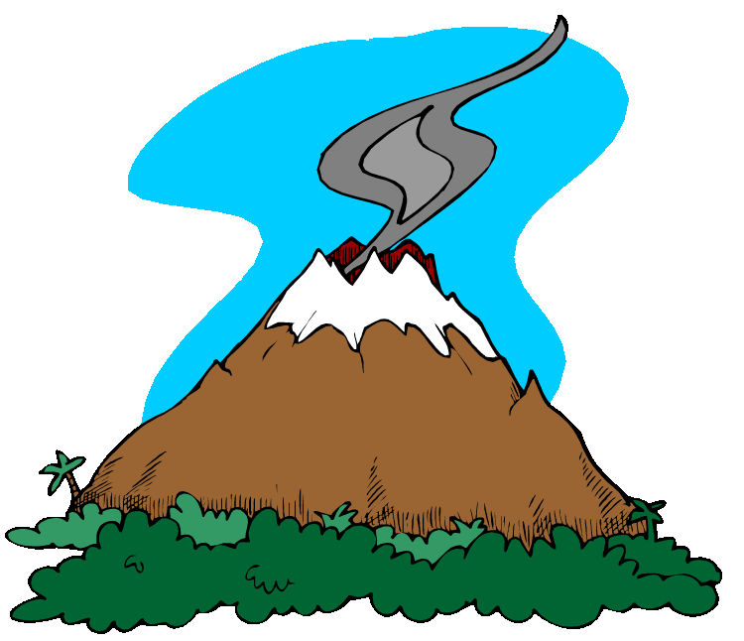
- Erupt the volcano. Can you use c14 to date the rock? Why, why not.

_________________________________________ ________________________________________ ________________________________________ _________________________________________ ________________________________________

Now try the Uranium 238.

- How long does it take for 10% of the Uranium to brake down?
________________________________________________________________________________________________________________________________________________________________________________________________________________________

- Would Uranium 238 be a good choice for estimating the age of an eruption that likely happened within the last million years? Why, why not.

________________________________________________________________________________________________________________________________________________________________________________________________________________________

Dating game play with the simulation to find the age of the objects and fill in the table.

Object | Age | Isotope used to estimate
House
Living tree
Dead tree
First skull
Cup
Second human skull
Dinosaur skull
Trilobite
Brown rock on the bottom

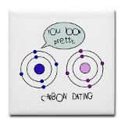

Or if that does not work try http://phet.colorado.edu/en/simulation/radioactive-dating-game#related-simulations

